CO3- AT3- Tree Traversal Challenges
Write the traversal sequences for following trees
Name : Moniga V
Register number : 192521184
Question No :1
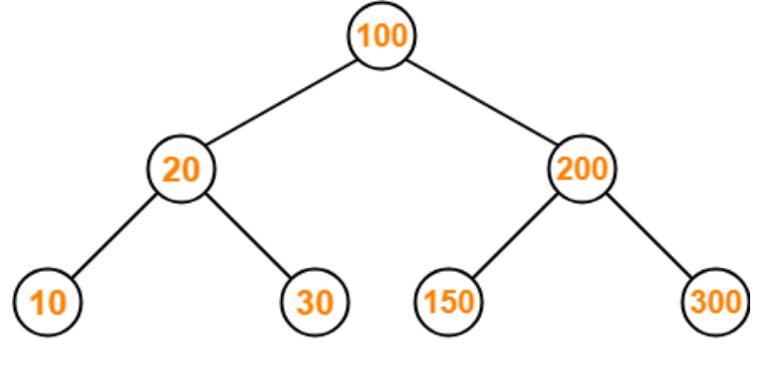

Inorder : 10,20,30,100,150,200,300
Preorder : 100,20,10,30,200,150,300
Postorder : 10,30,20,150,300,200,100
Question No : 2
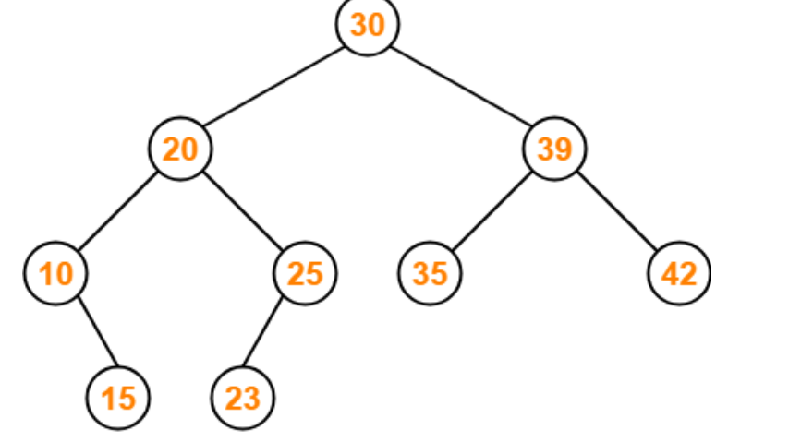
Inorder : 10,15,20,23,25,30,35,39,42
Preorder : 30,20,10,15,25,23,39,35,42
Postorder : 15,10,23,25,20,35,42,39,30

Question No : 3
Assume the digits 7, 5, 1, 8, 3, 6, 0, 9, 4, 2 are added in that sequence into a binary search tree that is initially empty. The binary search tree follows the standard natural number ordering. What is the resulting tree's traversal sequence?
7
/ \
5 8
/ \ \
1 6 9
/ \
- 3
/ \
2 4

Question No : 5
1
/ \
2 3
/ \ \
4 5 6
/
7
Inorder : 7,4,2,5,1,3,6
Preorder : 1,2,4,7,5,3,6
Postorder : 7,4,5,2,6,3,1

Question No 6
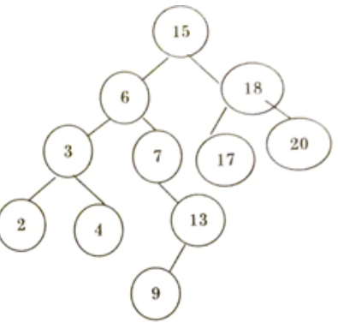
Inorder : 15,6,3,2,4,7,13,9,18,17,20
Preorder : 2,3,4,6,7,9,13,15,17,18,20
Postorder : 2,4,3,9,13,7,6,17,20,18,15

Question No 7
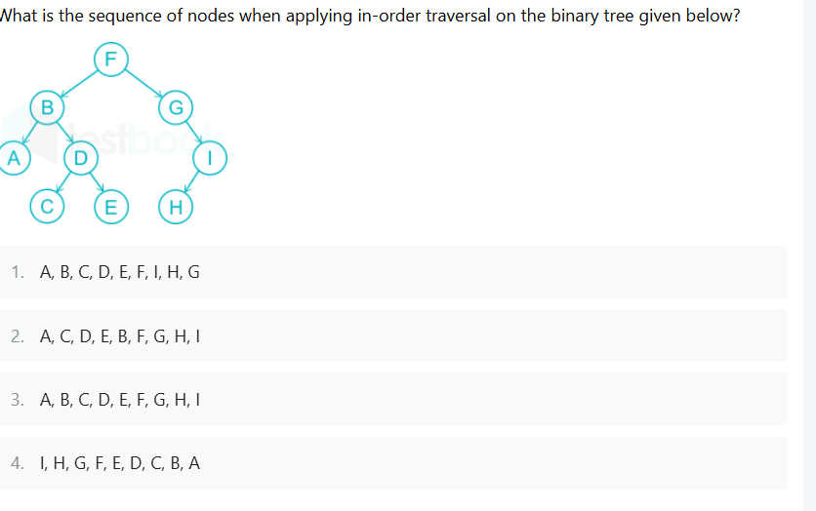
3 . A,B,C,D,E,F,G,H,I
Question No 8
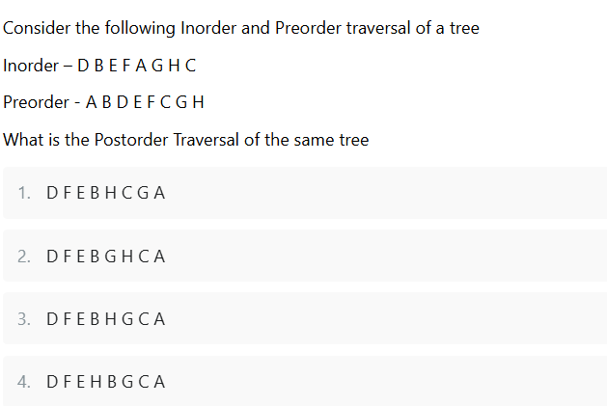
3 . D,F,E,B,H,G,C,A

Question No 9 : Find Inorder, Preorder and Postorder
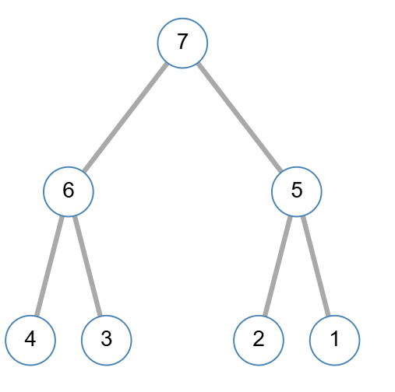
Inorder : 4,3,6,7,2,1,5
Preorder : 7,4,3,6,2,1,5
Postorder : 4,3,6,2,1,5,7

Question No 10
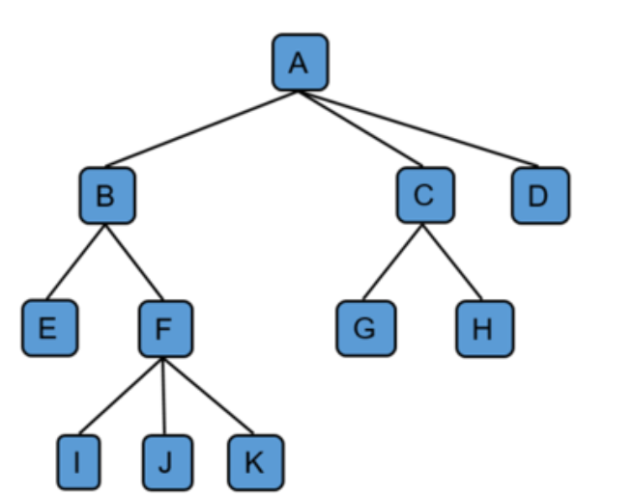
Preorder : A,B,E,F,I,J,C,G,D
Postorder : E,I,J,F,B,G,C,D,A

